國立東華大學姊妹校交流活動心得
National Dong Hwa University
Sister University Report

姓名Name | 謝于瑄 | 學號 Student No. | 410921379
系所及年級Department and Year | 資訊工程學系三年級
主辦學校 Host University | University of Oxford Hertford college
活動期間 Activity Period | 自From __2023__年year /___7___月month/___1___日date  至To ___2023___年year /___7___月month/___15___日date
課程：
我認為在口說以及聽力方面我認為是有非常大的幫助的。我也很喜歡老師上課時的互動內容、讓我們小組思考交流意見的時間、講出自己的想法以及有老師即時糾正你的文法錯誤等。課程內容也很多元，像是第一堂課下午就讓我們玩類似定向越野的學習單，讓我們熟悉牛津市中心的街道以及有名景點，也鼓勵我們去向路人問路。帶我們去參觀各種博物館，每一間博物館的展品都讓我大開眼界，印象最深刻的是去Ashmolean Museum寫學習單，雖然看起來很小間，但是裡面有來自世界各地的收藏，我認為光是這間博物館的館藏量就足以披敵台灣博物館的館藏量了。不只有坐在教室上課的內容，也有RA準備的運動時間、帶我們體驗PUB以及繪畫摺紙等課後休閒。
但是我覺第一週內容我認為有點過於簡單，或許可以再加深內容難度(像是英國歷史，僅有兩節課我認為無法概括到太多內容也不容易記憶)。
我比較喜歡第二週的上課內容，比較實用。像是如何用英文準備報告，以及帶我們體驗到如何寫CV以及英文面試，還有最後一天的全英文報告，對我來說算是非常有挑戰性的。
總結來說，我認為這次課程比較不像是去學習英文的，而是去體驗英國文化以及生活的。課程包含了很多方面的元素，老師很努力的想把聽說讀寫都包含進課程裡面，但是兩週真的不夠發揮，於是課程內容與深度就被犧牲了，我覺得非常可惜。
以下簡單附上課程時間規劃：
早上7:00學餐供應早餐(建議早點去避免排隊，或是自行準備)
早上9:00第一堂課開始
早上10:30到11:00有一個Tea Break可以喝茶喝咖啡吃茶點
早上11:00第二堂課開始，上到12:30吃午餐
午餐時間12:30到2:00
下午2:00上到4:00下課
下午4:00可能會排RA活動時間或是自由時間
下午5:00學餐吃晚餐
食：
由於Hertford college靠近市中心，而且旁邊有RA推薦的covered market，再加上基本三餐都是學餐解決(每天早餐基本差不多，只有中午晚餐會有變化，甜點若吃不了太甜請僅慎拿)，因此基本上不用擔心食物的部分。但是週末的時候學餐是沒有供餐的(僅有早餐)，若是想要外食我這邊推薦幾家並附上我當時點餐的價格作為參考：
Pieminister：每個派6磅起跳，會詢問你是否需要加馬鈴薯泥以及醬汁皆額外加價。有素食的派可供選擇，個人推薦Free ranger(雞肉派+一勺醬汁)。
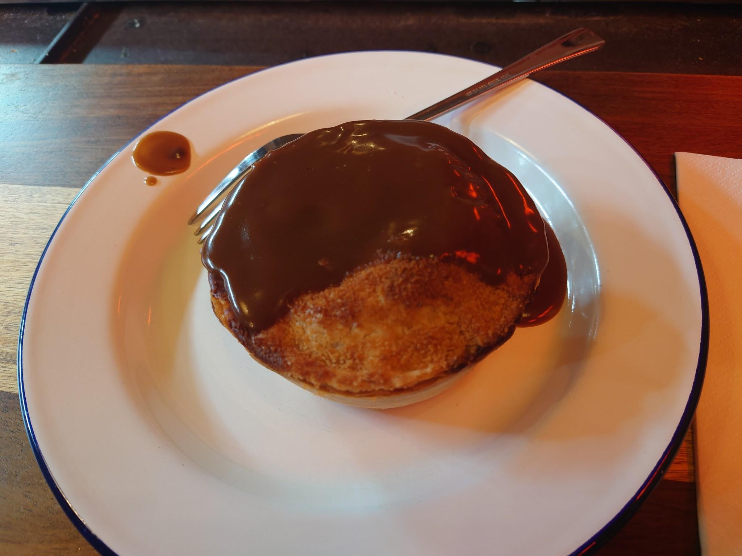
The Head of the River：只有去吃過早餐，門口會寫每天早餐時間，基本要訂位但早點去可以直接入座。早餐最便宜8磅起，點好之後會詢問你是否需要茶、咖啡還是果汁皆需要加2磅。個人認為相當好吃。
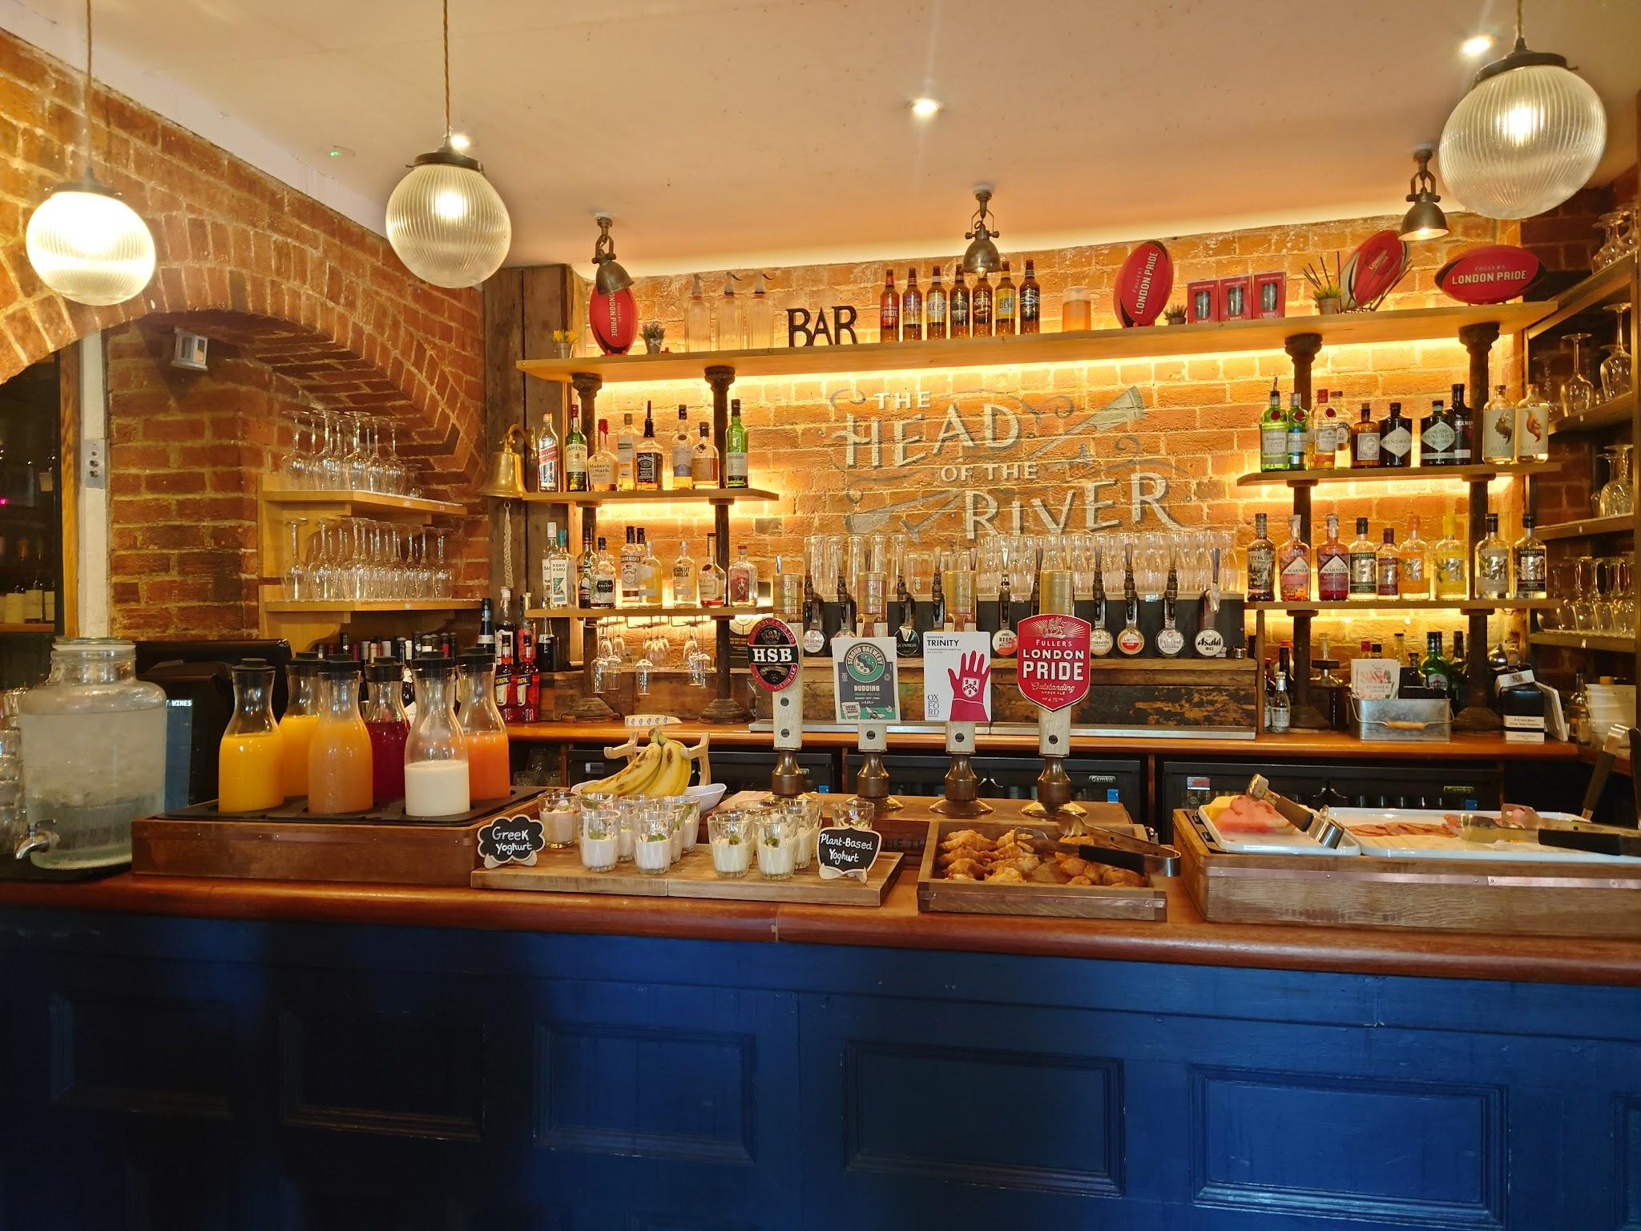
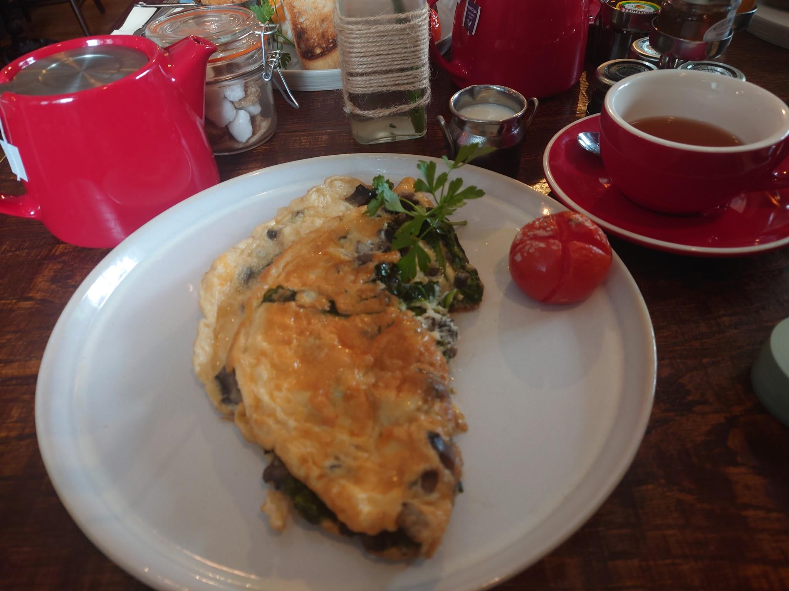
Wasabi：我最常去的餐廳，可以選擇內用或是帶走，內用會稍微貴一點。價格落在4到7磅左右，我覺得算是最接近亞洲口味的店，若是不習慣英式口味可以試試看這家。晚上9點有全店半價非常划算，一個便當只要3磅左右就可以買到(但是因為快要關店了所以只能刷卡)。
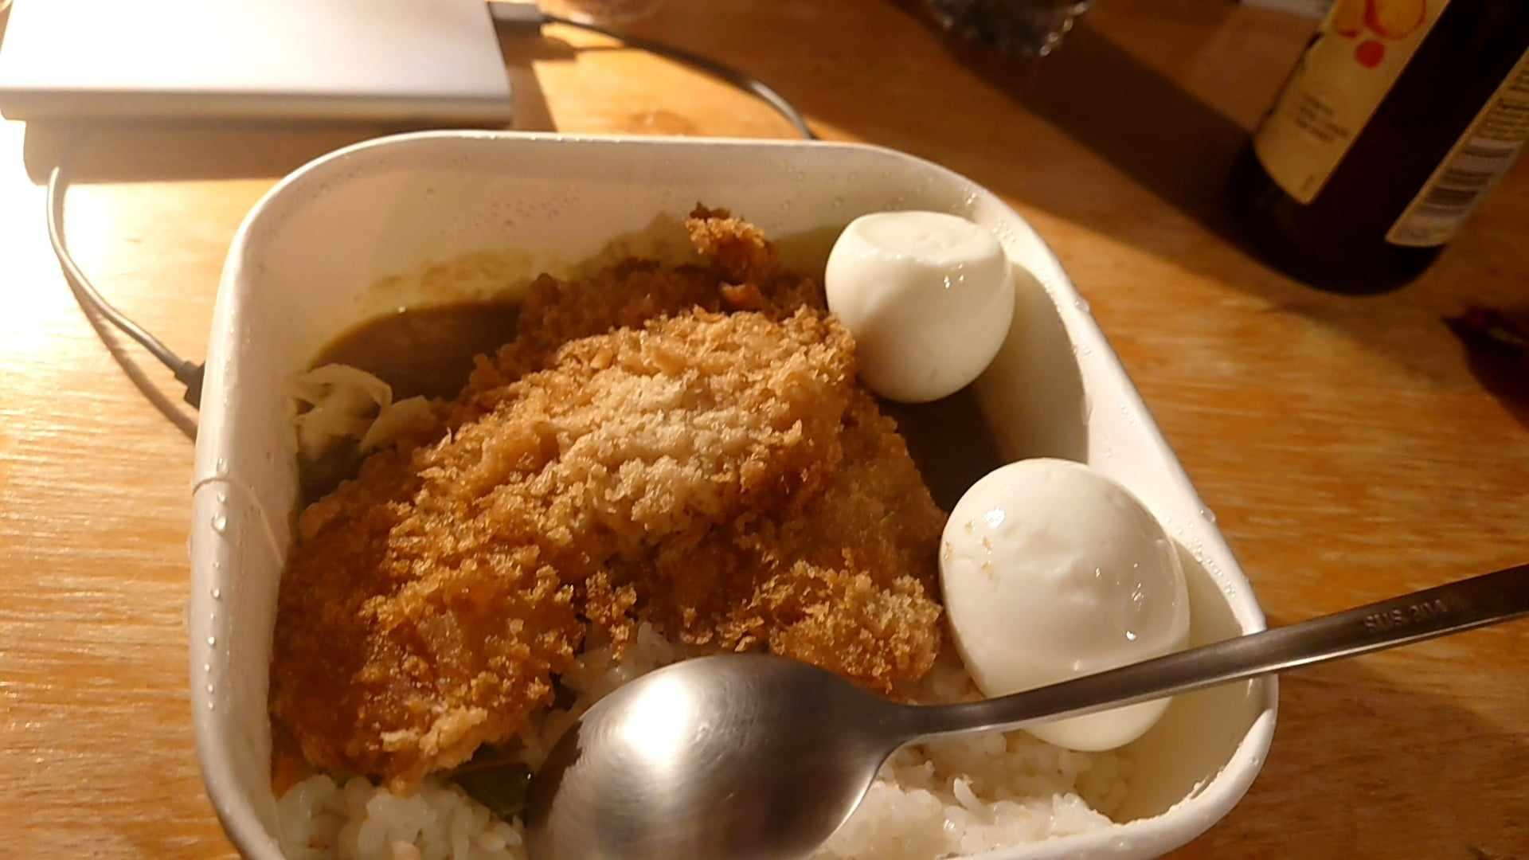
(蛋是Tesco買的)
Tesco：宿舍必經商店，像是便利商店，有各種微波食品跟即時食品可以選擇。主食搭配飲料及點心會有特別優惠價格，開到晚上11點，可以當消夜吃。
住+洗衣：
宿舍很溫馨，有衣櫃跟洗手台還有暖氣可以開，若是打不開可以請打掃人員幫你開。有窗戶可以打開，要注意會有蜜蜂或是其他蟲飛進去。打掃人員每天都會來幫你清除垃圾桶裡的垃圾，注意垃圾分類。每週換一次床單被套枕套跟浴巾。每層樓分兩邊，一邊大約住6人，共用一間淋浴間、兩間廁所，及一間廚房。廚房可以煮泡麵，使用冰箱還有微波爐。宿舍離學院有點遠，單趟大約15分鐘。(因為上課地點在宿舍樓下的小教室，所以若是不想出門吃早餐可以去Tesco買食品冰起來自己準備。此外牛奶很便宜，可以每天一瓶。)旁邊有居民住宅區，鄰近泰晤士河，可以散步，小心腳踏車。
有洗衣房，RA會帶你們去買洗衣卡，建議揪團一起洗(洗衣一次2.9磅，烘衣一次1.2磅，共4.1磅。一張洗衣卡2磅所以如果選擇10磅的卡裡面會只有8磅可以洗)，若是不夠的話可以線上刷卡儲值進卡裡。
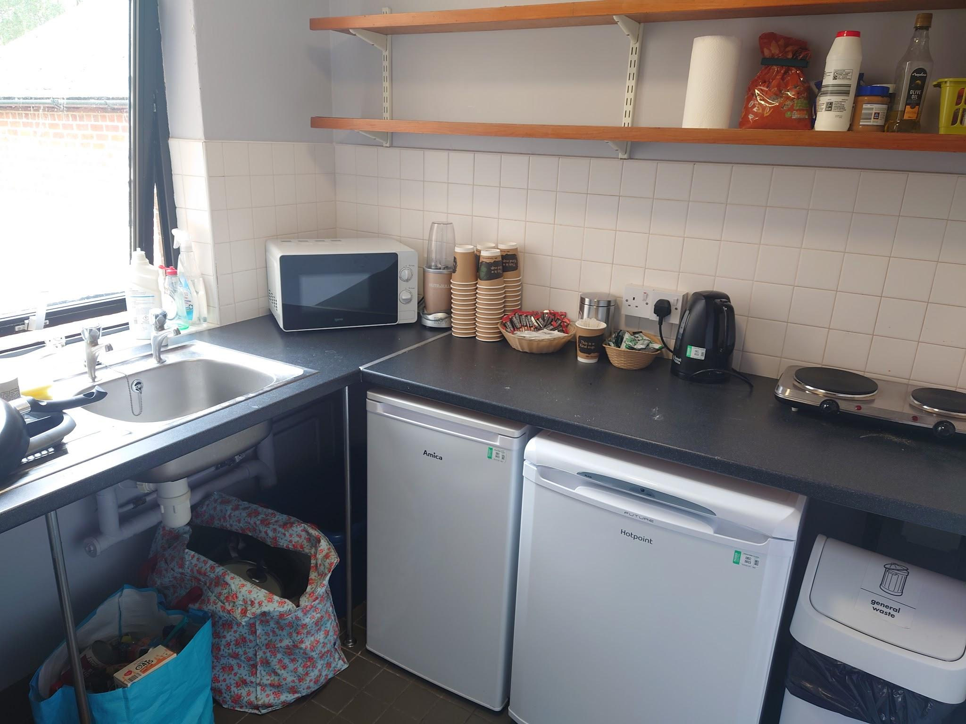

行+天氣：
平常日上課基本都是用走路的，每天平均10km上下。若是你有國際駕照，可以租路邊像是滑板車的電動車子。英國交通跟台灣相比非常貴，搭公車一次是2磅，上車可以選擇刷卡或是付現。且班次密集，幾乎所有景點都可以涵蓋到，需要注意站牌上的小英文字避免上錯車。
若是周末想去倫敦玩，非常建議揪團直接叫計程車，一個人大約是20磅左右(依據你的時間為準越晚越貴。若是搭機場快線去倫敦要25磅，還要轉車到你要的地方)。
天氣非常的陰晴不定，風也大，一定需要帶傘，或是防水防風外套。晴天的日子很少，但是一但太陽出來一定需要防曬。
旅遊+購物：
由於週末跟最後一天是自由時間所以可以自由行動，以下附上這次去的地方供參考：
Thorpe Park, London：英國最大的遊樂園，在倫敦郊區，去程車費35磅(機場快線25磅+10磅計程車費直達遊樂園門口)，回程車費大約在27磅左右(計程車約25磅+接駁車2磅)，建議揪團搭計程車前往。門票可以線上購買越早買越便宜(一星期前預購是34磅，當天購買是64磅)。遊樂園是10點開門，可以早點去，大約9點左右就會讓遊客入場排隊等待過安檢。可以先去排想玩的下午開始人就會變很多要排30分鐘以上，一整天基本逛不完，所以建議先規劃想玩的路線。
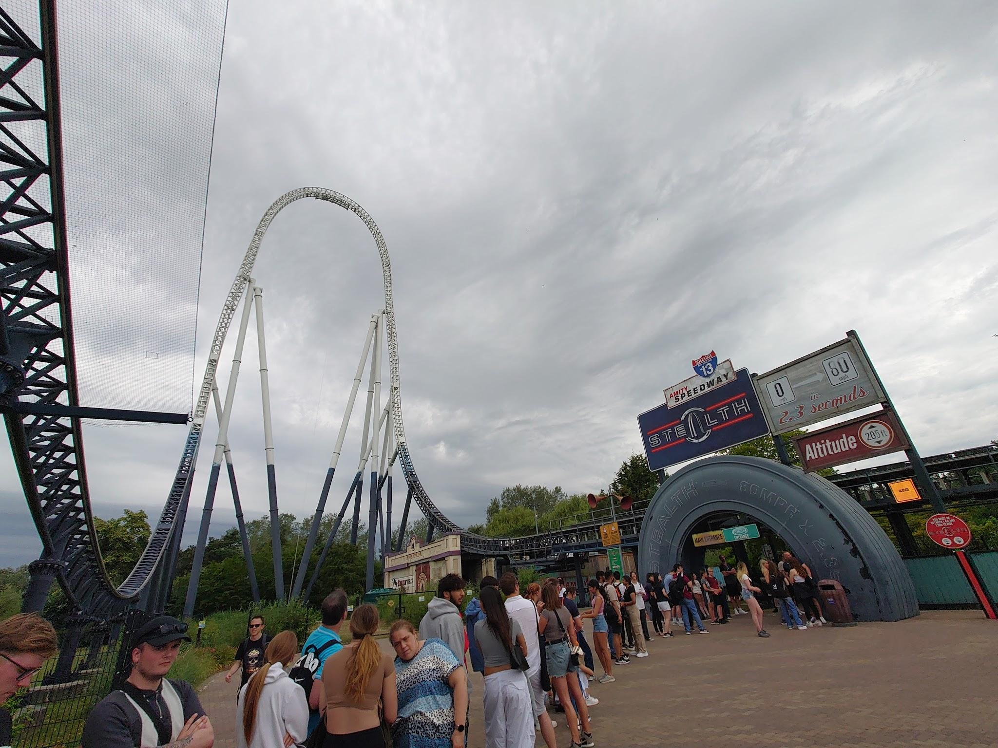
Bicester Village：牛津郊區的一個村莊，風景很美很好拍照，有一個很大的outlet可以購物休息，現場也有園區人員可以向他們問路。在Magdalen Street搭S5可以直達。
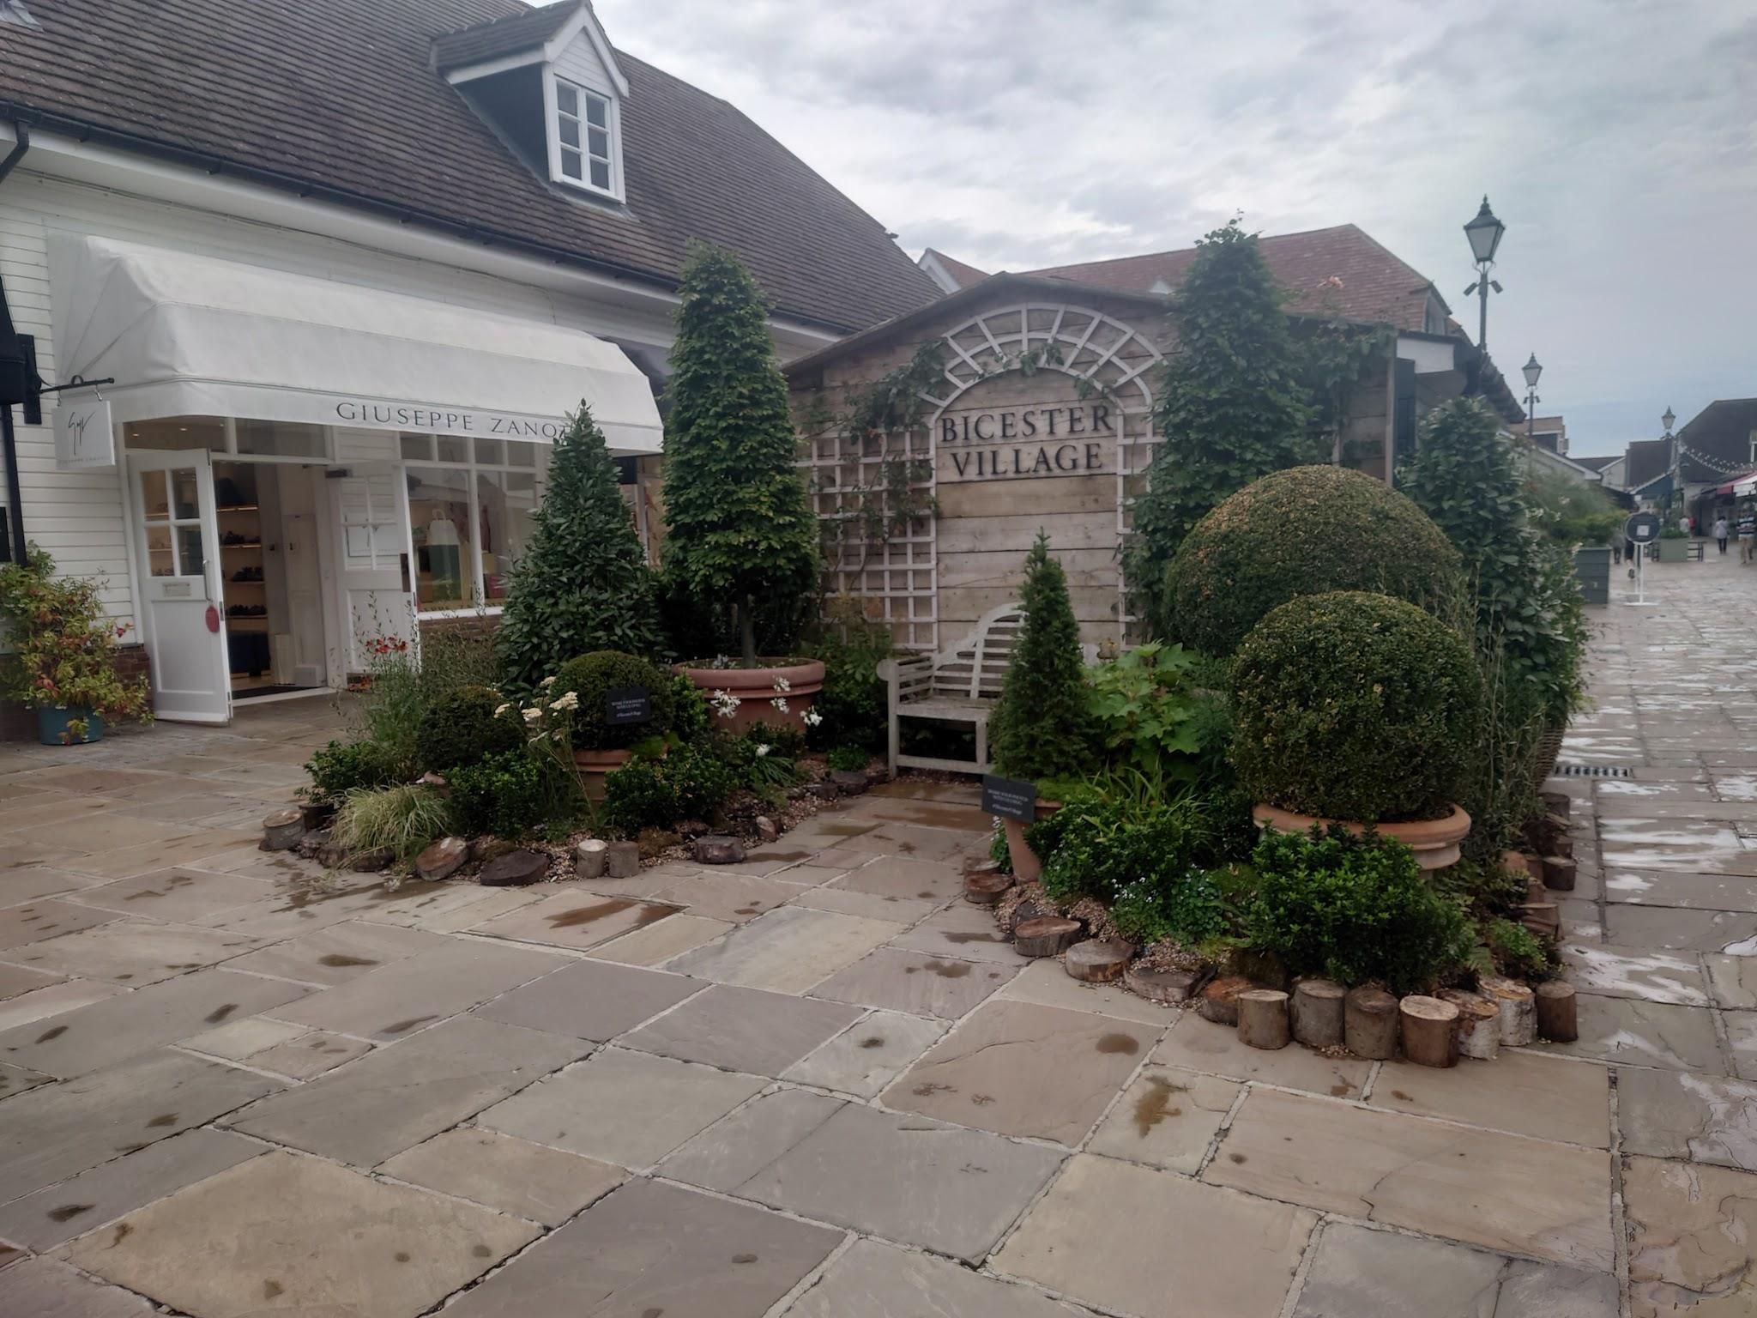
Sunmmertown：也是在Magdalen Street搭S5可以直達。整條街有很多地方可以逛，注意打烊時間。最有名的是Daunt Books這間書店的分店(類似台灣誠品的感覺)，也有當地的超大食品超市可以買一些食物帶回台灣，沿路也有很多咖啡廳跟pub走累了可以進去坐著休息，非常舒適的一個小鎮。
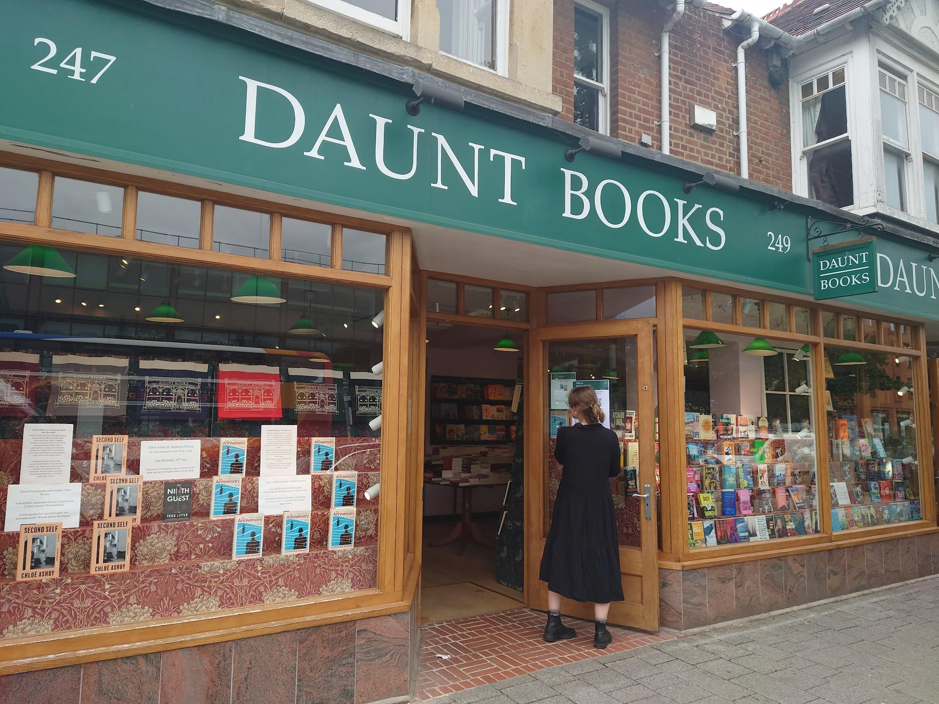
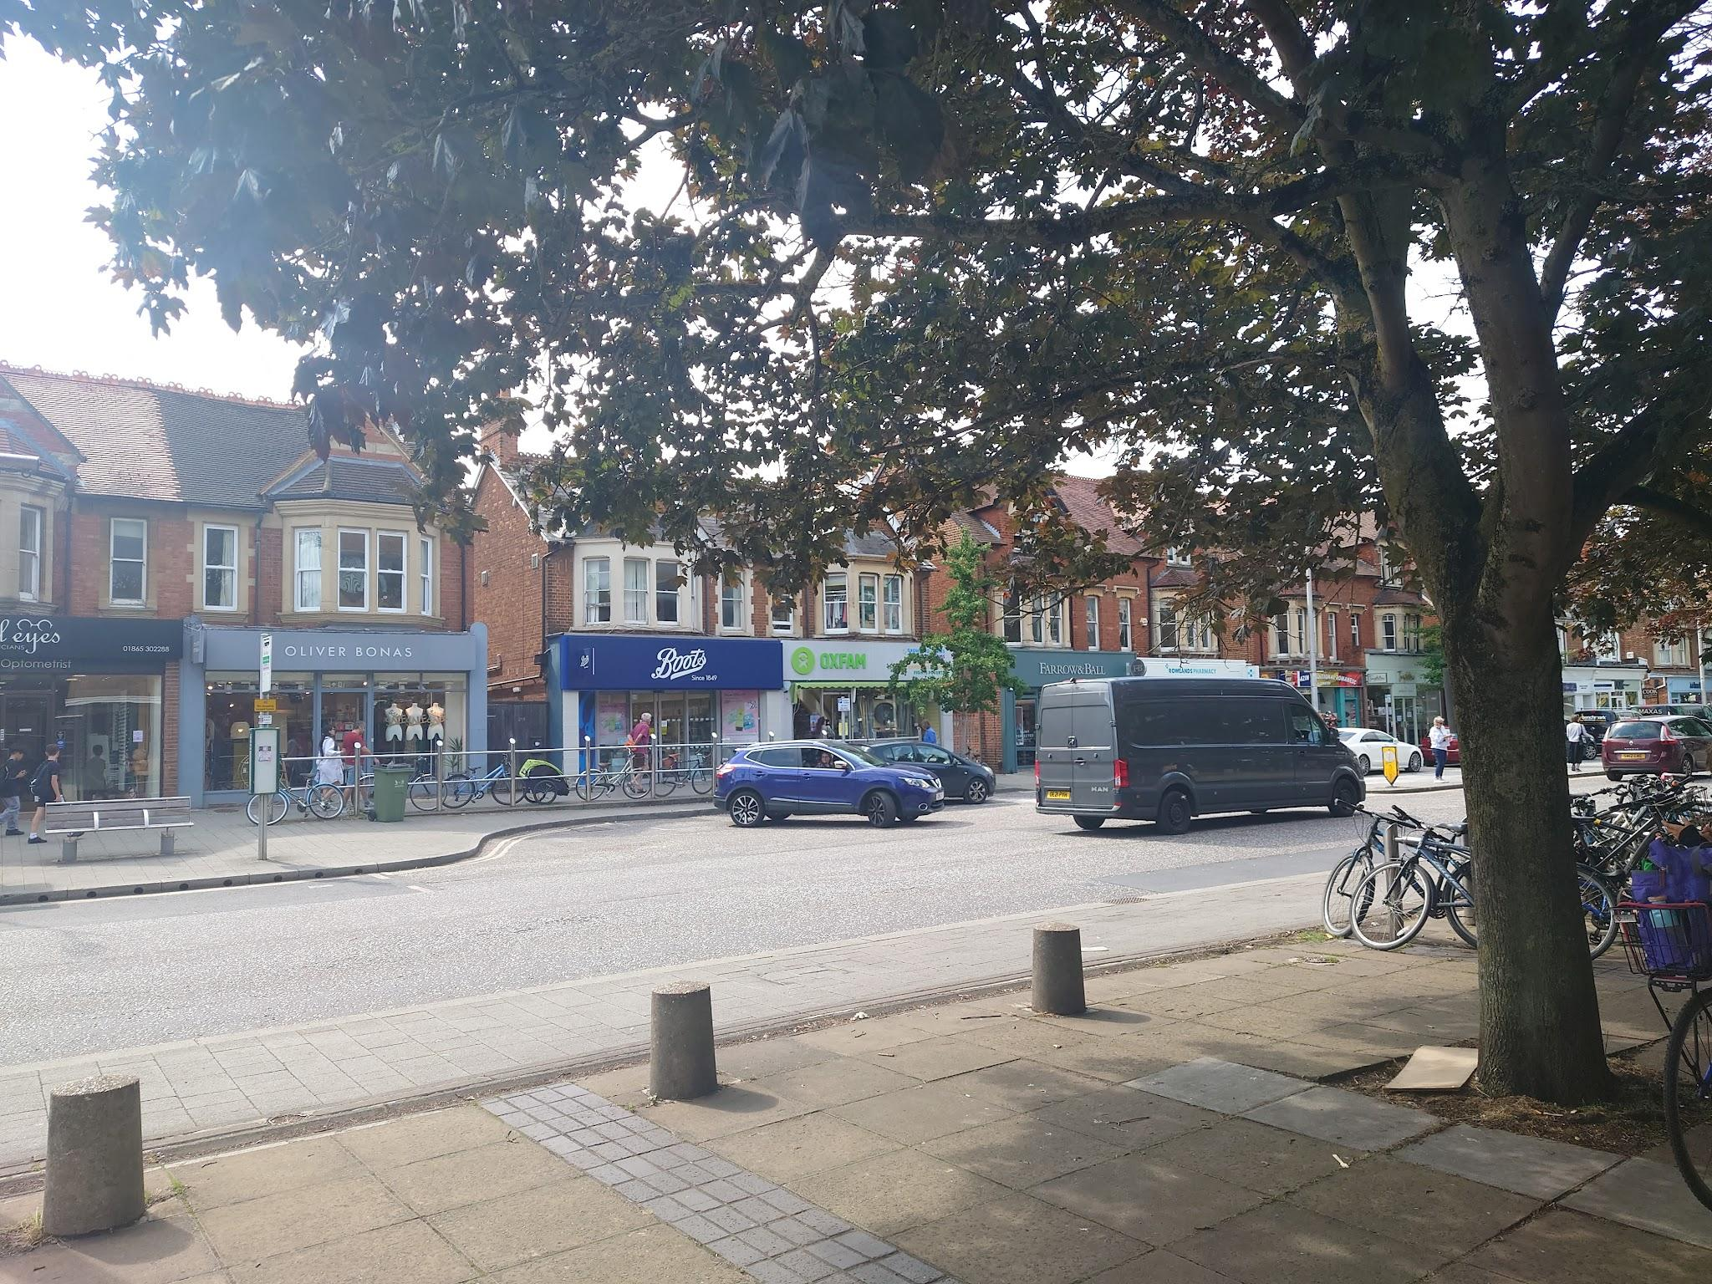
West Gate：百貨公司，裡面有很多店家，可以逛一整天。有很多店家都在打折。累了或是餓了也有美食街可以休息吃飯(價格偏高)。
Covered Market：很多當地小店家，可以買到新奇的東西，也有很多店家在打折，我個人認為比禮品店更適合買紀念品。餓了也有很多的餐廳可以選擇。
British Heart：在West Gate旁邊的一間二手衣店，裡面不只有男女裝可以挖寶，還有茶具、明信片、包包等，而且價格十分便宜，也有特價商品。
Whittard：很有名的茶店，有紅綠茶，也有花草茶，還有即溶茶咖啡可可，可以做選擇。有試喝以及試聞讓你選擇喜歡的味道。店員態度非常好，也會主動詢問是否需要幫忙，也可以請他們幫忙介紹。
Airport Tax Free：很便宜，尤其是香水，很多品牌可以慢慢逛。累了也有餐廳可以吃飯(極度不推Wagamama，日式料理店，covered market附近也有一家，但口味非常英式且貴)。
總結：
我認為這是一次難得的體驗。和牛津大學的學生交流；訓練口說聽力；和自己的課程裡的小組成員意見交流；和課程老師聊天；參觀各處的博物館，和當地人聊天等等，都是一個難忘的回憶。總結來說，經過這次課程我收穫了很多口說、聽力、CV以及面試技巧，但是希望能夠延長課程時間，讓課程內容再更深入一點。

